

**BTC2202 / ICS2014 : Computer Organization and Architecture**

**Assignment #2: Number System Conversion**

Rosy Waruku/ 120749

Maya Bororio/115878

Vicky Kimani/121472

Margaret Mugo/120791

The following document contains images of output from the code in questions 2(a) and 2(b) respectively. It also contains video recording of the running of the code.

**Question 2(a)**

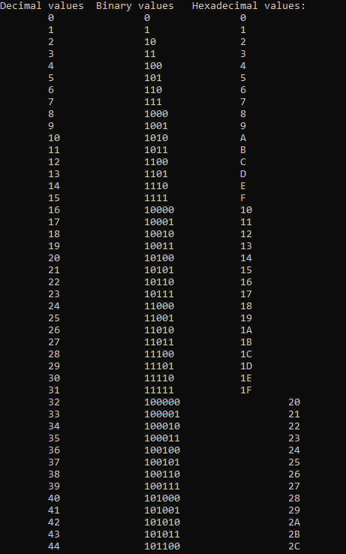

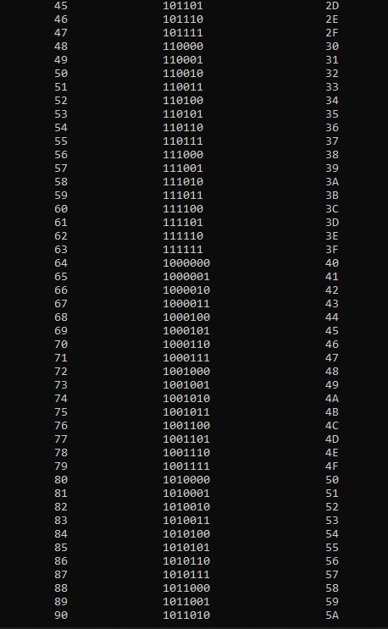

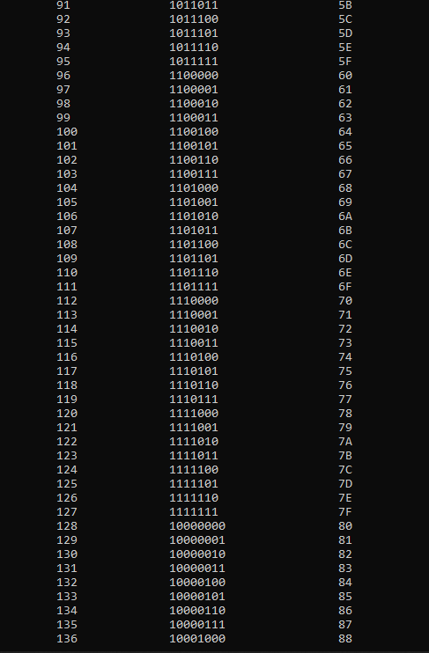

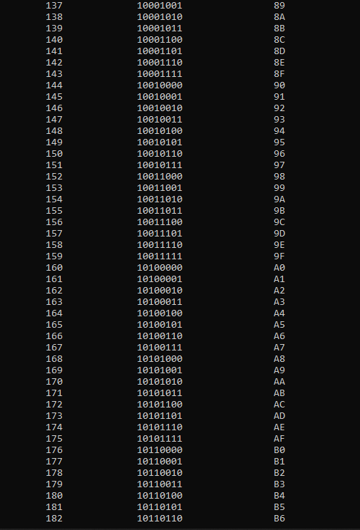

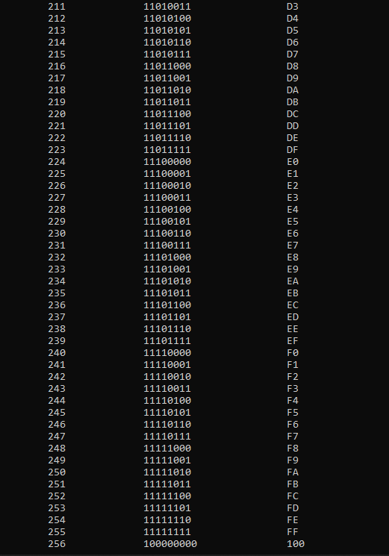



**Question 2(b)**

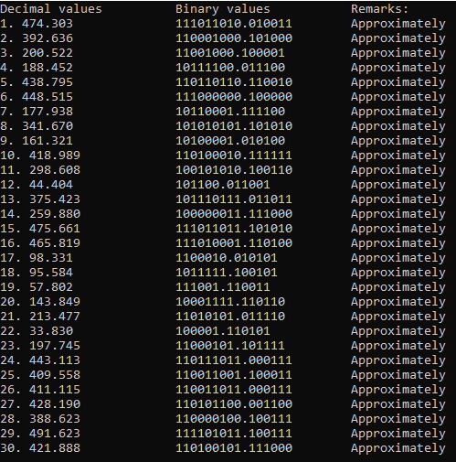



**References**

Convert decimal fraction to binary number in C++ . (2020). Retrieved December 17, 2020, from Tutorialspoint.com website: <https://www.tutorialspoint.com/convert-decimal-fraction-to-binary-number-in-cplusplus>